Name: Class: Mark:

1. An algorithm has been created which allows users to enter a number.
The number is added to a total. The user is then asked if they want to add another item. If they enter ‘Yes’ then they are asked to enter another number. If they enter ‘No’ the total is output and the program ends.
The following flowchart for the algorithm has been created.
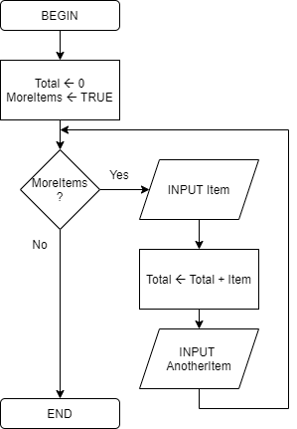
(a) The flowchart does not correctly implement the algorithm. Amend the flowchart to correctly reflect the scenario given. [8]

(b) Rewrite the algorithm using pseudocode. [4]
[Total 12 marks]

